NB Classwork

- Given the following dataset, apply the Naïve Bayes classifier to classify the new instance:
(Color = Green, legs=2, Height=Tall, and Smelly=No) whether it belongs to species M or H.
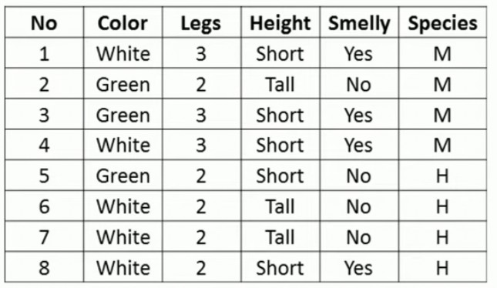

- Given the following dataset, apply the Naïve Bayes classifier to classify the new instance:
(Temp=Cool, Humidity=High)

